

Assignment Documentation

On

**Personal Expense Tracker App**

Submitted to

CipherSchools: [www.cipherschools.com](http://www.cipherschools.com) | Plutonn:[www.plutonn.com](http://www.plutonn.com) |Email: [support@cipherschools.com](mailto:support@cipherschools.com)

|  |  |
| --- | --- |
| **Submitted By:** | **GitHub Link** |
| Sumit Kumar (12319937) | [CipherSchools-Flutter-Assignmen](https://github.com/Sumitkr777/CipherSchools-Flutter-Assignment) |
| Sumitkayshap777@gmail.com |  |
|  |  |

**Submission Date**

**15-04-2025**

**Table of Contents**

|  |  |
| --- | --- |
| Topics | Page no |
| 1. Overview | 3 |
| 1. Features | 3 |
| 1. Technologies Used | 3 |
| 1. UI Screens | 4 |
| 1. Project Structure | 4 |
| 1. Flow chat | 5 |
| 1. Development Screenshot | 6 |
| 1. Installation and Setup | 6 |
| 1. Conclusions | 7 |
| 1. Future Improvements | 7 |

**1. Overview**

This Flutter application is a Personal Expense Tracker App that helps users track their income and expenses with a clean and intuitive UI. It includes Google Authentication and uses Firebase for cloud data storage and local databases for offline access.

**2. Features**

1. Add Income and Expense entries
2. Categorization: Food, Travel, Shopping, Subscriptions
3. Visual display of total income vs expenses
4. Google Sign-In authentication
5. Firestore integration for storing user data
6. Customize Profile

**3. Technologies Used**

|  |  |
| --- | --- |
| Tech | Purpose |
| Flutter | Cross-platform UI framework |
| Firebase Auth | Google Sign-In Authentication |
| Firestore | Cloud database for user info |
| Provider | State Management |
| Shared Preferences | Persistent login/session storage |
| Material Design | UI Components |

**4. UI Screens**

|  |  |
| --- | --- |
| Screen Name | Description |
| Initial Screen | Purple background with CipherX logo |
| Splash Screen | Welcome screen with navigation button |
| Login/Signup | User Authentication |
| Home | Main application interface |
| Profile Screen | User Settings |

**5. Project Structure**

|  |  |
| --- | --- |
|  |  |

**6. Flow chat**

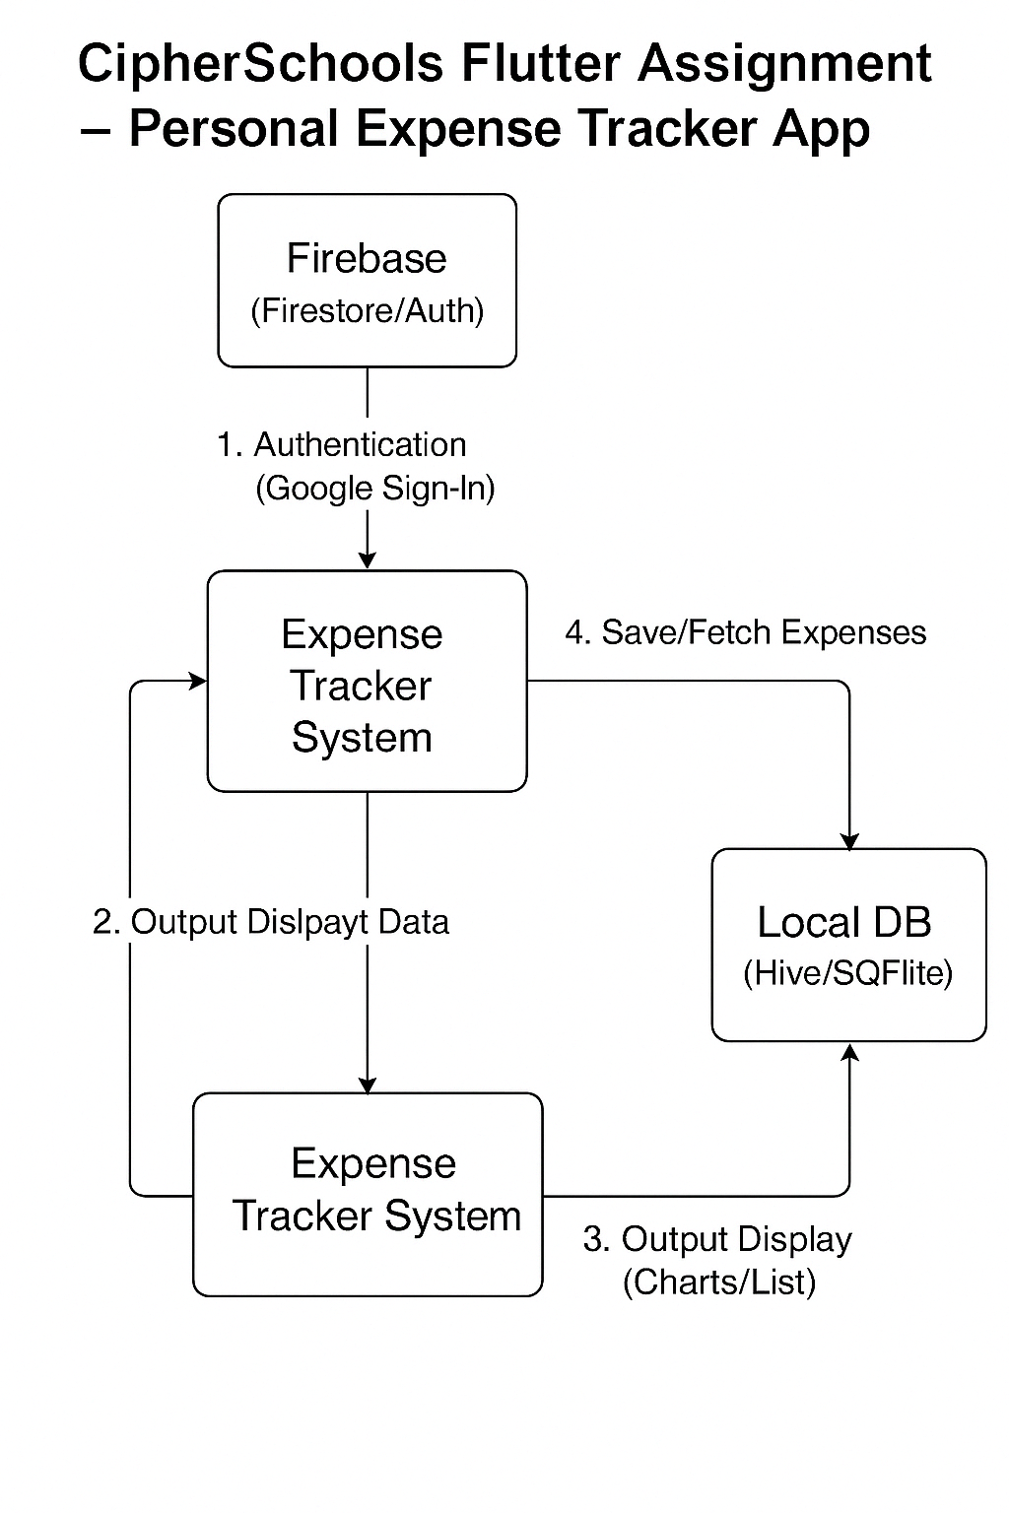

**7. Development Screenshot**

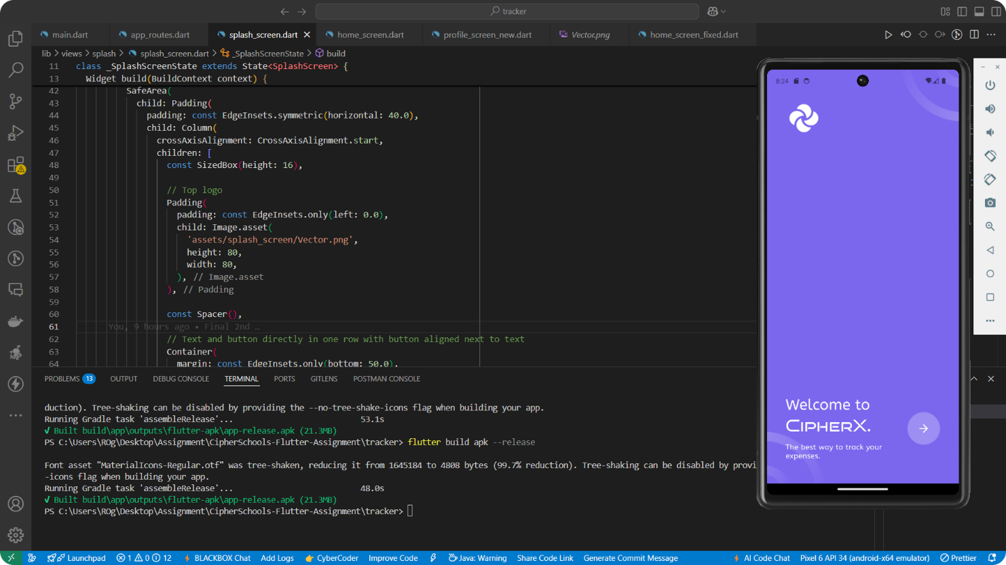

* **Firebase Setup**

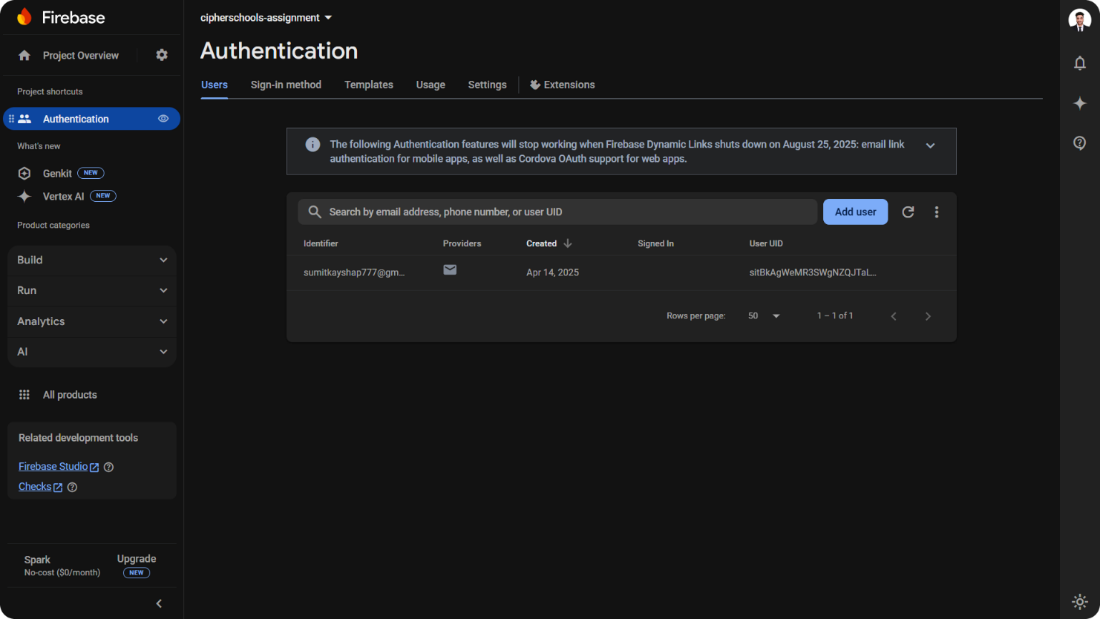

**8. Installation and Setup**

1. **Clone the repository**

git clone https://github.com/Sumitkr777/CipherSchools-Flutter-Assignment.git

cd CipherSchools-Flutter-Assignment/tracker

2. **Install dependencies**

flutter pub get

3. **Run the app**

flutter run

**9. Conclusions**

Overall, making this UI was a good experience. I worked on building a clean and easy-to-use design. The app runs fast and works well with Firebase and local databases. I used a simple and organized way to write the code, which made everything easier to handle. This project helped me build a smooth and useful app that is easy to use and ready to grow in the future.

**10. Future Improvements (If I could)**

* Cloud sync of transaction data
* Graph-based monthly analytics
* Budget planning and alerts
* Export data as PDF or CSV